EARL HAIG SECONDARY SCHOOL
ENG 4U1 Ten-Best-Arguments Summative

The final summative will be an exit-interview in the form of a podcast, based on ten best argumentative paragraphs.
All of your 250-word summative argument paragraphs should contain several common traits:
- They need to start with a topic sentence(s) that argues what the most interesting idea that you learned from a text.
- Ideas should make connections with other specific texts or specific experiences.
- They need to be interesting and show insight. Do not state the obvious
- They should employ verbs of analysis.
- They need to be authentic
  - They should not be a summary, or “rating” of the unit or text studied

Your task is to synthesize the first few classes into a 250 word reflection addressing what you learned from one of the first non-fiction articles or essays such as “The Danger of the Single Story” or “The Coddling of the American Mind.”
You should show your first draft of this to me, so that I can “eyeball” it and see if you are on the right track. When you have a final draft you will type it on a Word document and upload it to turnitin.com.

At the end of May, you will use your best ten arguments as the basis for your summative podcast.
Throughout the year you should complete your arguments at the end of each unit so that your connections and insights are authentic and you are able to complete your best work while it is still fresh in your memory.

- It is in your best interest to have your teachers “eyeball” an assignment well in advance of the due date. It is an exercise in being assertive. If you are interested in attaining top marks in a class, put your energy into the work before its final draft rather than receiving your final evaluation and asking to redo the assignment.

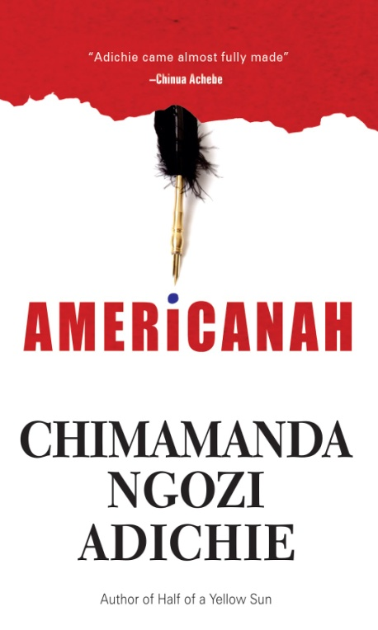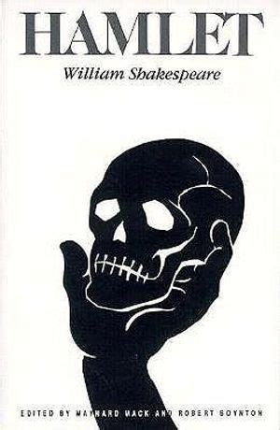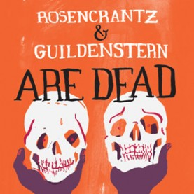

EARL HAIG SECONDARY SCHOOL
ENG 4U1 Argument Summative

Name: __________________________________________________________

Instructions:
- Complete your ten arguments in a timely manner and submit them to turnitin.com. Each should directly argue what the most interesting idea is in a text which should be linked to the question, “What did you learn?” Follow this with insightful observations and inter-textual connections.
- Divide and categorize your arguments.
- Highlight key insights in one colour and inter-textual connections another.

Podcast Interview
Be prepared to answer the following questions during your interview:
- Explain how you divided and categorized your arguments. What does this say about your interests?
- What did you learn this year?
- Predict what role literature, media studies, and writing will have in your future.
Interpret what you are interested in. What parts of this learning will continue to grow in your personal life, academic or professional life after graduation?

 | Below One  <50 % | Level One  50-59% | Level Two  60-69% | Level Three  70-79% | Level Four  80-100%
Thinking  ORAL  Ordering, dividing and categorizing your insights | Little or no evidence of organization | Limited evidence of organization | Some of organization | Considerable of organization |  | Thorough evidence of organization
Communication ORAL  Communicates in a clear coherent manner | Explains process with a voice that acts as a liability to the content. | Explains process with limited verbal energy; voice detracts from the content of the podcast | Explains process with some verbal energy; voice does not add to the content of the podcast | Explains process with an animated voice: clear-spoken podcast that supports the content. |  | Explains process with an engaging voice: clear-spoken podcast that enriches the content.
Communication  WRITTEN | Makes connections with, within, and between various contexts with a low degree of effectiveness | Makes connections with, within, and between various contexts with limited effectiveness | Makes connections with, within, and between various contexts with some effectiveness | Makes connections with, within, and between various contexts with considerable effectiveness |  | Makes connections with, within, and between various contexts with a high degree of effectiveness
Application  WRITTEN  Timely Completion  Style  highlighting | Expresses and organizes insights with a low degree of effectiveness | Expresses and organizes insights with limited effectiveness | Expresses and organizes insights with some effectiveness | Expresses and organizes insights with considerable effectiveness. |  | Expresses and organizes insights with a high degree of effectiveness

Oral Mark Written Mark

Comments:

